**SQL HACKER RANK**

* **BASIC SELECT**

1. **Revising the Select Query I**

Query all columns for all American cities in the **CITY** table with populations larger than 100000. The **CountryCode** for America is USA.

The **CITY** table is described as follows:

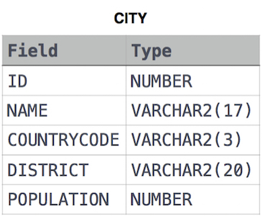

**Ans:**

**select * from city where population>100000 and countrycode='USA'**

1. **Revising the Select Query II**

Query the **NAME** field for all American cities in the **CITY** table with populations larger than 120000. The CountryCode for America is USA.

The **CITY** table is described as follows:  


**Ans:**

**select name from city where population >120000 and countrycode='USA'**

1. **Select ALL**

Query all columns (attributes) for every row in the **CITY** table.

The **CITY** table is described as follows:  


**Ans:**

**select * from city ;**

1. **Select By ID**

Query all columns for a city in **CITY** with the ID 1661.

The **CITY** table is described as follows:  


**Ans:**

**select * from city where ID=1661 ;**

1. **Japanese Cities Attributes**

Query all attributes of every Japanese city in the **CITY** table. The **COUNTRYCODE** for Japan is JPN.

The **CITY** table is described as follows:  


**Ans:**

**select * from city where COUNTRYCODE = 'JPN' ;**

1. **Japanese Cities Names**

Query the names of all the Japanese cities in the **CITY** table. The **COUNTRYCODE** for Japan is JPN.  
The **CITY** table is described as follows:  


**Ans:**

**select name from city where countrycode='JPN';**

1. **Weather Observation Station 1**

Query a list of **CITY** and **STATE** from the **STATION** table.  
The **STATION** table is described as follows:

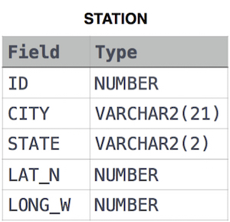  
where **LAT_N** is the northern latitude and **LONG_W** is the western longitude.

**Ans: select city,state from station ;**

1. **Weather Observation Station 3**

Query a list of **CITY** names from **STATION** for cities that have an even **ID** number. Print the results in any order, but exclude duplicates from the answer.  
The **STATION** table is described as follows:



where **LAT_N** is the northern latitude and **LONG_W** is the western longitude.

**Ans:**

**select distinct city from station where ID%2 = 0 ;**

1. **Weather Observation Station 4**

Find the difference between the total number of **CITY** entries in the table and the number of distinct **CITY** entries in the table.  
The **STATION** table is described as follows:



where **LAT_N** is the northern latitude and **LONG_W** is the western longitude.

For example, if there are three records in the table with **CITY** values 'New York', 'New York', 'Bengalaru', there are 2 different city names: 'New York' and 'Bengalaru'. The query returns 1, because

Total no. of records – number of unique city names = 3-2 =1

**Ans:**

**select count(city) - count(distinct city) from station ;**

1. **Weather Observation Station 5**

Query the two cities in **STATION** with the shortest and longest *CITY* names, as well as their respective lengths (i.e.: number of characters in the name). If there is more than one smallest or largest city, choose the one that comes first when ordered alphabetically.  
The **STATION** table is described as follows:



where **LAT_N** is the northern latitude and **LONG_W** is the western longitude.

**Sample Input**

For example, **CITY** has four entries: **DEF, ABC, PQRS** and **WXY**.

**Sample Output**

ABC 3

PQRS 4

**Explanation**

When ordered alphabetically, the **CITY** names are listed as **ABC, DEF, PQRS,** and **WXY**, with lengths 3,3,4 and 3 . The longest name is **PQRS**, but there are  3 options for shortest named city. Choose **ABC**, because it comes first alphabetically.

**Note**  
You can write two separate queries to get the desired output. It need not be a single query.

**Ans:**

**select CITY, length(CITY) from STATION order by length(CITY), CITY limit 1;**

**select CITY, length(CITY) from STATION order by length(CITY) desc, CITY limit 1;**

1. **Weather Observation Station 6**

Query the list of CITY names starting with vowels (i.e., a, e, i, o, or u) from **STATION**. Your result cannot contain duplicates.

**Input Format**

The **STATION** table is described as follows:



where LAT_N is the northern latitude and LONG_W is the western longitude.

**Ans:**

**SELECT DISTINCT(CITY) FROM STATION WHERE CITY LIKE 'A%' OR CITY LIKE 'E%' OR CITY LIKE 'I%' OR CITY LIKE 'O%' OR CITY LIKE 'U%' ORDER BY CITY ASC ;**

1. **Weather Observation Station 7**

Query the list of CITY names ending with vowels (a, e, i, o, u) from **STATION**. Your result cannot contain duplicates.

**Input Format**

The **STATION** table is described as follows:



where LAT_N is the northern latitude and LONG_W is the western longitude.

**Ans:**

**select distinct city from station where city like '%a' or city like '%e' or city like '%i' or city like '%o' or city like '%u';**

1. **Weather Observation Station 8**

Query the list of CITY names from **STATION** which have vowels (i.e., a, e, i, o, and u) as both their first and last characters. Your result cannot contain duplicates.

**Input Format**

The **STATION** table is described as follows:



where LAT_N is the northern latitude and LONG_W is the western longitude.

**Ans:**

**select distinct city from station where city like '%a' or city like '%e' or city like '%i' or city like '%o' or city like '%u';**

1. **Weather Observation Station 9**

Query the list of CITY names from **STATION** that do not start with vowels. Your result cannot contain duplicates.

**Input Format**

The **STATION** table is described as follows:



where LAT_N is the northern latitude and LONG_W is the western longitude.

**Ans:**

**select distinct city from station where city not like 'a%' or city not like 'e%' or city not like 'i%' or city not like 'o%' or city not like 'u%'**

1. **Weather Observation Station 10**

Query the list of CITY names from **STATION** that do not end with vowels. Your result cannot contain duplicates.

**Input Format**

The **STATION** table is described as follows:



where LAT_N is the northern latitude and LONG_W is the western longitude

**Ans:**

**select distinct city from station where city not like '%a' and city not like '%e' and city not like '%i' and city not like '%o' and city not like '%u'**

1. **Weather Observation Station 11**

Query the list of CITY names from **STATION** that either do not start with vowels or do not end with vowels. Your result cannot contain duplicates.

**Input Format**

The **STATION** table is described as follows:



where LAT_N is the northern latitude and LONG_W is the western longitude.

**Ans:**

**select distinct city from station where (city not like '%a' and city not like '%e' and city not like '%i' and city not like '%o' and city not like '%u') or (city not like 'a%' and city not like 'e%' and city not like 'i%' and city not like 'o%' and city not like 'u%')**

1. **Weather Observation Station 12**

Query the list of CITY names from **STATION** that either do not start with vowels and do not end with vowels. Your result cannot contain duplicates.

**Input Format**

The **STATION** table is described as follows:



where LAT_N is the northern latitude and LONG_W is the western longitude.

**Ans:**

**select distinct city from station where (city not like '%a' and city not like '%e' and city not like '%i' and city not like '%o' and city not like '%u') and (city not like 'a%' and city not like 'e%' and city not like 'i%' and city not like 'o%' and city not like 'u%')**

1. **Higher than 75 Marks**

Query the Name of any student in **STUDENTS** who scored higher than  75 Marks. Order your output by the last three characters of each name. If two or more students both have names ending in the same last three characters (i.e.: Bobby, Robby, etc.), secondary sort them by ascending ID.

**Input Format**

The **STUDENTS** table is described as follows: 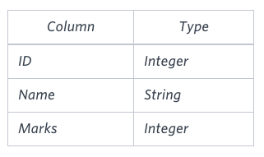 The Name column only contains uppercase (A-Z) and lowercase (a-z) letters.

**Sample Input**

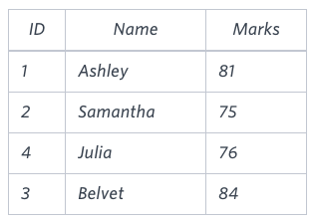

**Sample Output**

Ashley

Julia

Belvet

**Explanation**

Only Ashley, Julia, and Belvet have Marks > 75 . If you look at the last three characters of each of their names, there are no duplicates and 'ley' < 'lia' < 'vet'.

**Ans:**

**select name from students where marks >75**

**order by right(name,3) asc, ID asc;**

1. **Employee Names**

Write a query that prints a list of employee names (i.e.: the name attribute) from the **Employee** table in alphabetical order.

**Input Format**

The **Employee** table containing employee data for a company is described as follows:

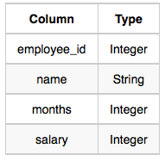

where employee_id is an employee's ID number, name is their name, months is the total number of months they've been working for the company, and salary is their monthly salary.

**Sample Input**

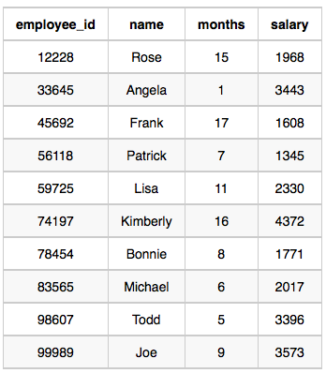

**Sample Output**

Angela

Bonnie

Frank

Joe

Kimberly

Lisa

Michael

Patrick

Rose

Todd

**Ans:**

**select name from employee order by name;**

1. **Employee Salaries**

Write a query that prints a list of employee names (i.e.: the name attribute) for employees in **Employee** having a salary greater than *$2000* per month who have been employees for less than *10* months. Sort your result by ascending employee_id.

**Input Format**

The **Employee** table containing employee data for a company is described as follows:



where employee_id is an employee's ID number, name is their name, months is the total number of months they've been working for the company, and salary is the their monthly salary.

**Sample Input**



**Sample Output**

Angela

Michael

Todd

Joe

**Explanation**

Angela has been an employee for 1 month and earns $3443 per month.  
Michael has been an employee for 6 months and earns $2017 per month.  
Todd has been an employee for 5 months and earns $3396 per month.  
Joe has been an employee for 9 months and earns $3573 per month.  
We order our output by ascending employee_id.

**Ans:**

**select name from employee where salary > 2000 and months < 10**

**order by employee_id asc;**

* **ADVANCE SELECT**

1. **Type of Triangle**

Write a query identifying the *type* of each record in the **TRIANGLES** table using its three side lengths. Output one of the following statements for each record in the table:

* **Equilateral**: It's a triangle with 3  sides of equal length.
* **Isosceles**: It's a triangle with  2 sides of equal length.
* **Scalene**: It's a triangle with  3 sides of differing lengths.
* **Not A Triangle**: The given values of *A*, *B*, and *C* don't form a triangle.

**Input Format**

The **TRIANGLES** table is described as follows:

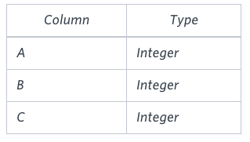

Each row in the table denotes the lengths of each of a triangle's three sides.

**Sample Input**

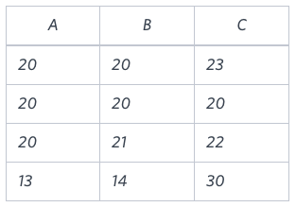

**Sample Output**

Isosceles

Equilateral

Scalene

Not A Triangle

**Explanation**

Values in the tuple  form an Isosceles triangle, because .  
Values in the tuple  form an Equilateral triangle, because . Values in the tuple  form a Scalene triangle, because .  
Values in the tuple  cannot form a triangle because the combined value of sides  and  is not larger than that of side .

**Ans:**

**MYSQL**

**SELECT**

**CASE**

**WHEN (A + B <= C) OR (B + C <= A) OR (A + C <= B) THEN 'Not A Triangle'**

**WHEN (A = B) AND (B = C) THEN 'Equilateral'**

**WHEN ((A = B) &(A != C)) OR ((B = C) &(B != A)) OR ((A = C) &(A != B)) THEN 'Isosceles'**

**WHEN (A != B) AND (B != C) AND (A != C) THEN 'Scalene'**

**END AS Triangle_Type**

**FROM**

**TRIANGLES;**

**MS SQL SERVER**

**SELECT CASE**

**WHEN A + B <= C OR A + C <= B OR B + C <= A THEN 'Not A Triangle'**

**WHEN A = B AND B = C THEN 'Equilateral'**

**WHEN A = B OR B = C OR A = C THEN 'Isosceles'**

**ELSE 'Scalene'**

**END**

**FROM TRIANGLES;**

1. **The PADS**

Generate the following two result sets:

1. Query an alphabetically ordered list of all names in OCCUPATIONS, immediately followed by the first letter of each profession as a parenthetical (i.e.: enclosed in parentheses). For example: AnActorName(A), ADoctorName(D), AProfessorName(P), and ASingerName(S).
2. Query the number of ocurrences of each occupation in OCCUPATIONS. Sort the occurrences in ascending order, and output them in the following format:  
   There are a total of [occupation_count] [occupation]s.  
   where [occupation_count] is the number of occurrences of an occupation in OCCUPATIONS and [occupation] is the lowercase occupation name. If more than one Occupation has the same [occupation_count], they should be ordered alphabetically.

***Note:*** There will be at least two entries in the table for each type of occupation.

***Input Format***  
The OCCUPATIONS table is described as follows:

Occupation will only contain one of the following values: Doctor, Professor, Singer or Actor.

***Sample Input***  
An OCCUPATIONS table that contains the following records:

***Sample Output***  
Ashely(P)  
Christeen(P)  
Jane(A)  
Jenny(D)  
Julia(A)  
Ketty(P)  
Maria(A)  
Meera(S)  
Priya(S)  
Samantha(D)  
There are a total of 2 doctors.  
There are a total of 2 singers.  
There are a total of 3 actors.  
There are a total of 3 professors.

**Ans:**

**MYSQL**

**select concat(name,"(",left(occupation,1),")") from occupations**

**order by name asc;**

**select concat("There are a total of ",count(occupation)," ",lower(occupation), "s.") from occupations**

**group by occupation**

**order by count(occupation) asc,occupation;**

1. **Occupations**

[Pivot](https://en.wikipedia.org/wiki/Pivot_table) the Occupation column in **OCCUPATIONS** so that each Name is sorted alphabetically and displayed underneath its corresponding Occupation. The output column headers should be Doctor, Professor, Singer, and Actor, respectively.

**Note:** Print **NULL** when there are no more names corresponding to an occupation.

**Input Format**

The **OCCUPATIONS** table is described as follows:

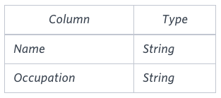

Occupation will only contain one of the following values: **Doctor**, **Professor**, **Singer** or **Actor**.

**Sample Input**

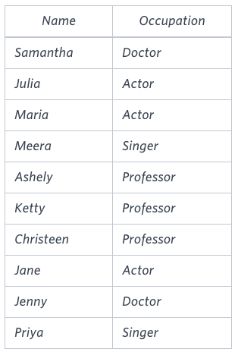

**Sample Output**

Jenny Ashley Meera Jane

Samantha Christeen Priya Julia

NULL Ketty NULL Maria

**Explanation**

The first column is an alphabetically ordered list of Doctor names.  
The second column is an alphabetically ordered list of Professor names.  
The third column is an alphabetically ordered list of Singer names.  
The fourth column is an alphabetically ordered list of Actor names.  
The empty cell data for columns with less than the maximum number of names per occupation (in this case, the Professor and Actor columns) are filled with **NULL** values.

**Ans:**

**MYSQL**

**CREATE VIEW pq AS (**

**SELECT**

**CASE WHEN occupation = 'Doctor' THEN name END AS 'Doctor',**

**CASE WHEN occupation = 'Professor' THEN name END AS 'Professor',**

**CASE WHEN occupation = 'Singer' THEN name END AS 'Singer',**

**CASE WHEN occupation = 'Actor' THEN name END AS 'Actor',**

**ROW_NUMBER() OVER (PARTITION BY occupation ORDER BY name) as cr**

**FROM occupations**

**);**

**SELECT MAX(Doctor),MAX(Professor),MAX(Singer),MAX(Actor) FROM pq**

**GROUP BY cr;**

**OR**

**Select Doctor, Professor, Singer, Actor from ( select  
NameOrder,  
max(case Occupation when 'Doctor' then Name end) as Doctor,  
max(case Occupation when 'Professor' then Name end) as Professor,  
max(case Occupation when 'Singer' then Name end) as Singer,  
max(case Occupation when 'Actor' then Name end) as Actor  
from ( select Occupation, Name, row_number() over(partition by Occupation order by Name ASC) as NameOrder from Occupations ) as NameLists group by NameOrder  
) as Names**

1. **Binary Tree Nodes**

You are given a table, *BST*, containing two columns: *N*and *P,* where *N* represents the value of a node in *Binary Tree*, and *P* is the parent of *N*.

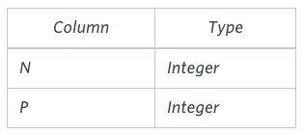

Write a query to find the node type of *Binary Tree* ordered by the value of the node. Output one of the following for each node:

* *Root*: If node is root node.
* *Leaf*: If node is leaf node.
* *Inner*: If node is neither root nor leaf node.

**Sample Input**

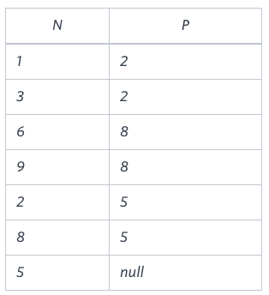

**Sample Output**

1 Leaf

2 Inner

3 Leaf

5 Root

6 Leaf

8 Inner

9 Leaf

**Explanation**

The *Binary Tree* below illustrates the sample:

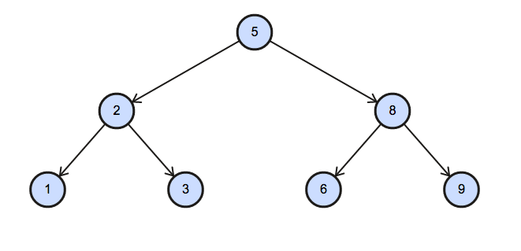

**Ans:**

**MYSQL**

**SELECT N,**

**CASE**

**WHEN P is NULL THEN 'Root'**

**WHEN N in (SELECT P FROM BST) THEN 'Inner'**

**ELSE 'Leaf'**

**END as node_type**

**FROM BST**

**ORDER by N;**

1. **New Companies**

Amber's conglomerate corporation just acquired some new companies. Each of the companies follows this hierarchy: 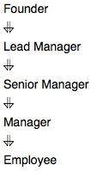

Given the table schemas below, write a query to print the *company_code*, *founder* name, total number of *lead* managers, total number of *senior* managers, total number of *managers*, and total number of *employees*. Order your output by ascending *company_code*.

**Note:**

* The tables may contain duplicate records.
* The *company_code* is string, so the sorting should not be **numeric**. For example, if the *company_codes* are *C_1*, *C_2*, and *C_10*, then the ascending *company_codes* will be *C_1*, *C_10*, and *C_2*.

**Input Format**

The following tables contain company data:

* *Company:* The *company_code* is the code of the company and *founder* is the founder of the company. 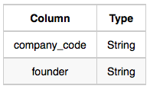
* *Lead_Manager:* The *lead_manager_code* is the code of the lead manager, and the *company_code* is the code of the working company. 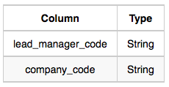
* *Senior_Manager:* The *senior_manager_code* is the code of the senior manager, the *lead_manager_code* is the code of its lead manager, and the *company_code* is the code of the working company. 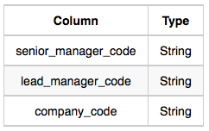
* *Manager:* The *manager_code* is the code of the manager, the *senior_manager_code* is the code of its senior manager, the *lead_manager_code* is the code of its lead manager, and the *company_code* is the code of the working company. 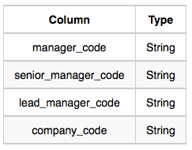
* *Employee:* The *employee_code* is the code of the employee, the *manager_code* is the code of its manager, the *senior_manager_code* is the code of its senior manager, the *lead_manager_code* is the code of its lead manager, and the *company_code* is the code of the working company. 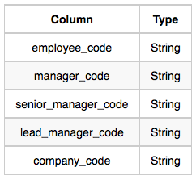

**Sample Input**

*Company* Table: 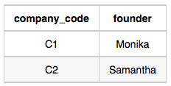 *Lead_Manager* Table: 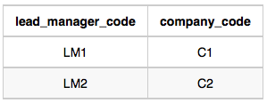 *Senior_Manager* Table: 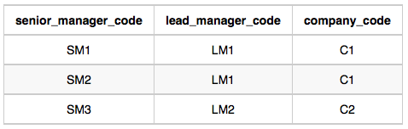 *Manager* Table: 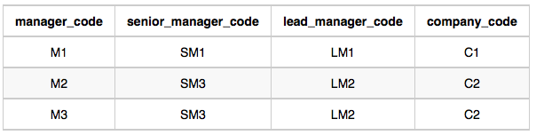 *Employee* Table: 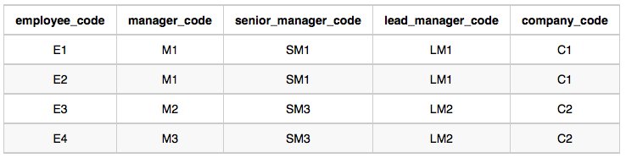

**Sample Output**

C1 Monika 1 2 1 2

C2 Samantha 1 1 2 2

**Explanation**

In company *C1*, the only lead manager is *LM1*. There are two senior managers, *SM1* and *SM2*, under *LM1*. There is one manager, *M1*, under senior manager *SM1*. There are two employees, *E1* and *E2*, under manager *M1*.

In company *C2*, the only lead manager is *LM2*. There is one senior manager, *SM3*, under *LM2*. There are two managers, *M2* and *M3*, under senior manager *SM3*. There is one employee, *E3*, under manager *M2*, and another employee, *E4*, under manager, *M3*.

**Ans:**

**MYSQL**

**select a.company_code,a.founder,count(distinct b.lead_manager_code), count(distinct b.senior_manager_code),count(distinct b.manager_code),**

**count(distinct b.employee_code) from**

**Company as a join employee as b**

**on a.company_code=b.company_code**

**group by a.company_code,a.founder**

**order by a.company_code asc;**

**OR**

**select c.company_code, c.founder, count(distinct l.lead_manager_code),  
count(distinct s.senior_manager_code), count(distinct m.manager_code),  
count(distinct e.employee_code) from**

**Company as c join Lead_Manager as l   
on c.company_code = l.company_code  
join Senior_Manager as s  
on l.lead_manager_code = s.lead_manager_code  
join Manager as m   
on m.senior_manager_code = s.senior_manager_code  
join Employee as e  
on e.manager_code = m.manager_code  
group by c.company_code, c.founder  
order by c.company_code;**

* **AGGREGATION**

1. **Revising aggregation – The Count Function**

Query a count of the number of cities in **CITY** having a Population larger than .100000

**Input Format**

The **CITY** table is described as follows: 

**Ans:**

**MYSQL**

**SELECT COUNT(NAME) FROM CITY WHERE POPULATION > 100000 ;**

1. **Revising aggregation – The Sum Function**

Query the total population of all cities in **CITY** where District is **California**.

**Input Format**

The **CITY** table is described as follows: 

**Ans:**

**select sum(population) from city where district ='California';**

1. **Revising aggregation – Average**

Query the average population of all cities in **CITY** where District is **California**.

**Input Format**

The **CITY** table is described as follows: 

**Ans:**

**select avg (population) from city where district = 'California';**

1. **Average Population**

Query the average population for all cities in **CITY**, rounded down to the nearest integer.

**Input Format**

The **CITY** table is described as follows: 

**Ans:**

**select floor(avg(population)) from city;**

1. **Japan Population**

Query the sum of the populations for all Japanese cities in **CITY**. The COUNTRYCODE for Japan is **JPN**.

**Input Format**

The **CITY** table is described as follows: 

**Ans:**

**select sum(population) from city where countrycode='JPN';**

1. **Population Density Difference**

Query the difference between the maximum and minimum populations in **CITY**.

**Input Format**

The **CITY** table is described as follows: 

**Ans:**

**select max(population) - min(population) from city;**

1. **The Blunder**

Samantha was tasked with calculating the average monthly salaries for all employees in the **EMPLOYEES** table, but did not realize her keyboard's  key was broken until after completing the calculation. She wants your help finding the difference between her miscalculation (using salaries with any zeros removed), and the actual average salary.

Write a query calculating the amount of error (i.e.:  average monthly salaries), and round it up to the next integer.

**Input Format**

The **EMPLOYEES** table is described as follows:

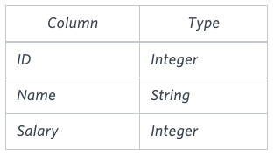

**Note:** Salary is per month.

**Constraints**

.

**Sample Input**

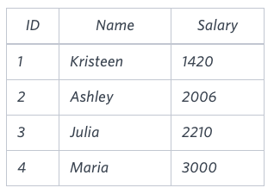

**Sample Output**

2061

**Explanation**

The table below shows the salaries without zeros as they were entered by Samantha:

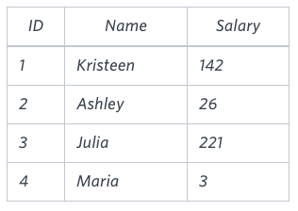

Samantha computes an average salary of . The actual average salary is .

The resulting error between the two calculations is . Since it is equal to the integer , it does not get rounded up.

**Ans:**

**select max(population) - min(population) from city;**

1. **Top Earners**

We define an employee’s total earnings to be their monthly salary* months worked, and the maximum total earnings to be the maximum total earnings for any employee in the Employee table. Write a query to find the maximum total earnings for all employees as well as the total number of employees who have maximum total earnings. Then print these values as space-separated integers.

Input Format

The Employee table containing employee data for a company is described as follows:

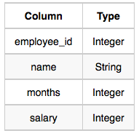

where employee_id is an employee’s ID number, name is their name, months is the total number of months they’ve been working for the company, and salary is the their monthly salary.

Sample Input

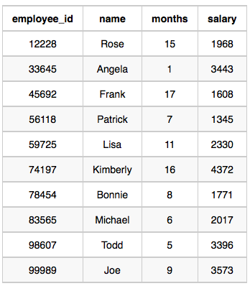

Sample Output

69952 1

Explanation

The table and earnings data is depicted in the following diagram:

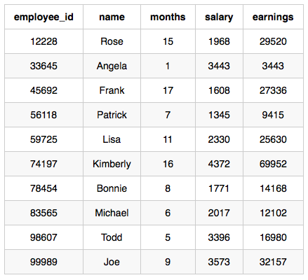

The maximum earnings value is 69952. The only employee with earnings 69952 is Kimberly, so we print the maximum earnings value (69952) and a count of the number of employees who have earned 69952 (which is 1) as two space-separated values.

**Ans:**

**select months*salary, count(*) from employee**

**group by months*salary**

**order by months*salary desc**

**limit 1;**

1. **Weather Observation Station 2**

Query the following two values from the **STATION** table:

1. The sum of all values in *LAT_N* rounded to a scale of 2  decimal places.
2. The sum of all values in *LONG_W* rounded to a scale of  2 decimal places.

**Input Format**

The **STATION** table is described as follows:



where *LAT_N* is the northern latitude and *LONG_W* is the western longitude.

**Output Format**

Your results must be in the form:

lat lon

where lat  is the sum of all values in *LAT_N* and  lon is the sum of all values in *LONG_W*. Both results must be rounded to a scale of 2  decimal places.

**Ans:**

**select round(sum(LAT_N),2) AS lat , round(sum(LONG_W),2) as lon from STATION;**

1. **Weather Observation Station 13**

Query the sum of Northern Latitudes (LAT_N) from **STATION** having values greater than  38.7880 and less than 137.2345 . Truncate your answer to  4 decimal places.

**Input Format**

The **STATION** table is described as follows:



where LAT_N is the northern latitude and LONG_W is the western longitude.

**Ans:**

**select round(sum(lat_n),4) from station where lat_n>38.7880 and lat_n<137.2345;**

1. **Weather Observation Station 14**

Query the greatest value of the Northern Latitudes (LAT_N) from **STATION** that is less than . Truncate your answer to  decimal places.

**Input Format**

The **STATION** table is described as follows:



where LAT_N is the northern latitude and LONG_W is the western longitude.

**Ans:**

**SELECT ROUND(MAX(LAT_N),4) FROM STATION WHERE LAT_N < 137.345;**